**Phase 3: Automation with Flows & Processes**

1. **Objective of this Phase**

The purpose of Phase 3 was to **automate loyalty program logic** using **Flows** and **Approval Processes** instead of relying only on manual updates.  
We ensured that:

* Orders automatically update loyalty points.
* Loyalty Tier syncs to the Contact.
* Inactive customers get re-engagement emails.
* Errors are logged automatically for troubleshooting.

**2. Record-Triggered Flows Created**

We built several **Record-Triggered Flows** to handle business logic:

**2.1 Add Loyalty Points on Order Activation**

**Trigger**: Order object → When Status = Activated.

**Steps inside Flow**:

1. **Get Loyalty Member** (linked via Contact).
2. **Decision** → Check if Order has TotalAmount > 0.
3. **Assignment** → Calculate points = FLOOR(TotalAmount / 100).
4. **Update Loyalty Member** → Add points to Loyalty_Points_Balance__c.
5. **Create Loyalty Points History** → Log transaction (Points, Order, Reason = “Order Activated”).
6. **Fault Path** → If any step fails, log in Error_Log__c.

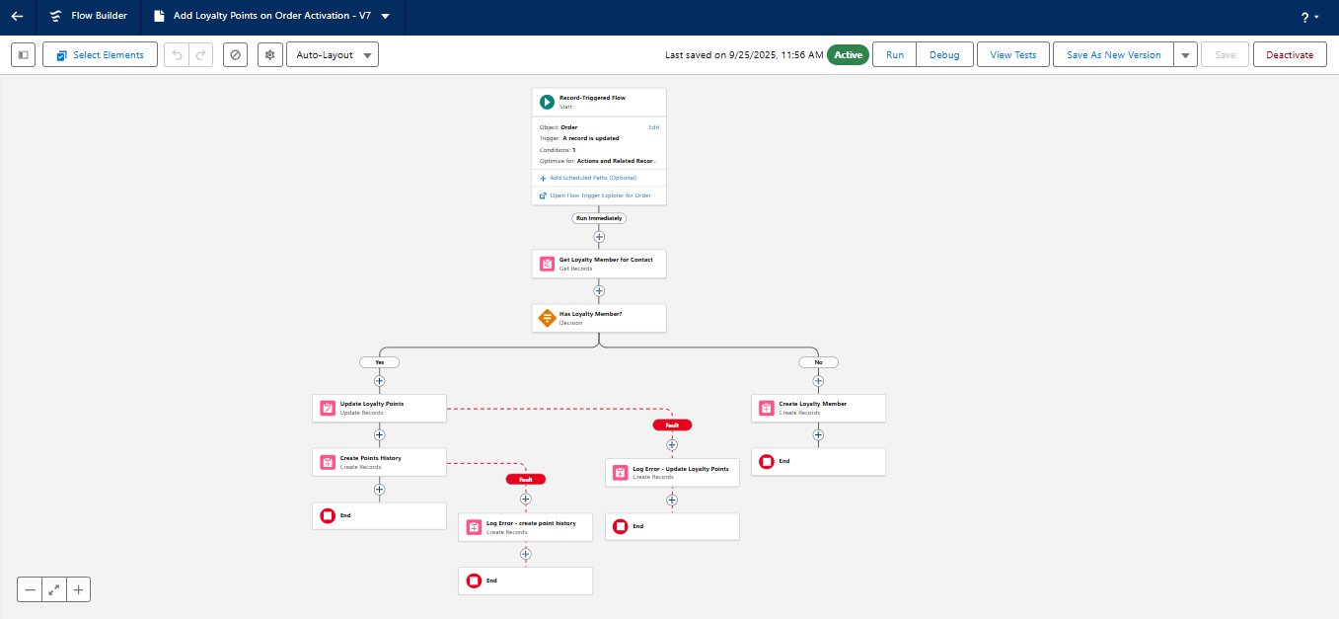

**2.2 Sync Loyalty Tier to Contact**

**Trigger**: Loyalty_Member__c → On Create/Update.

**Steps inside Flow**:

1. **Decision** → Check if Loyalty_Tier__c is populated.
2. **Update Contact** → Set Primary_Loyalty_Tier__c = Loyalty Member’s Tier.
3. **Fault Path** → Log error in Error_Log__c.

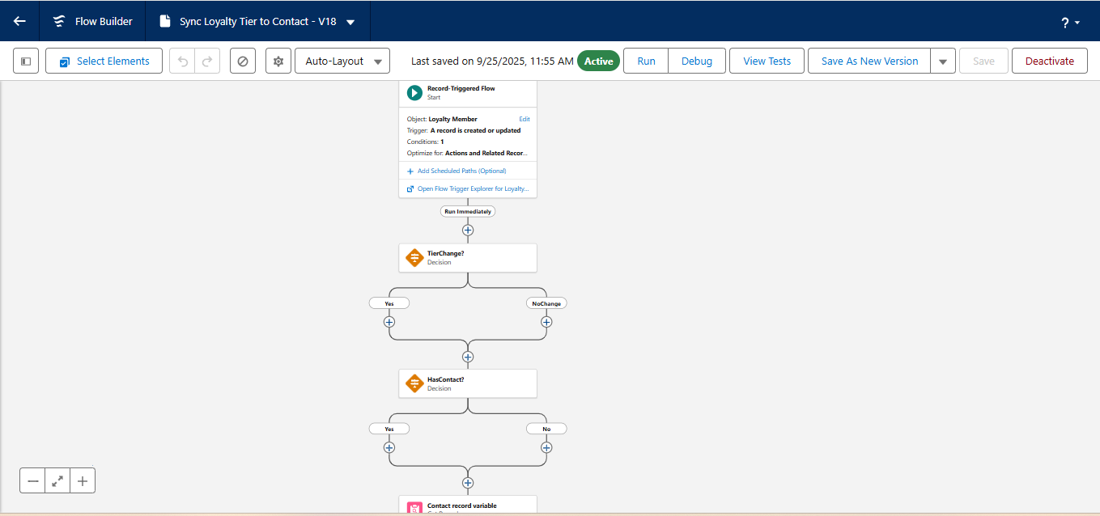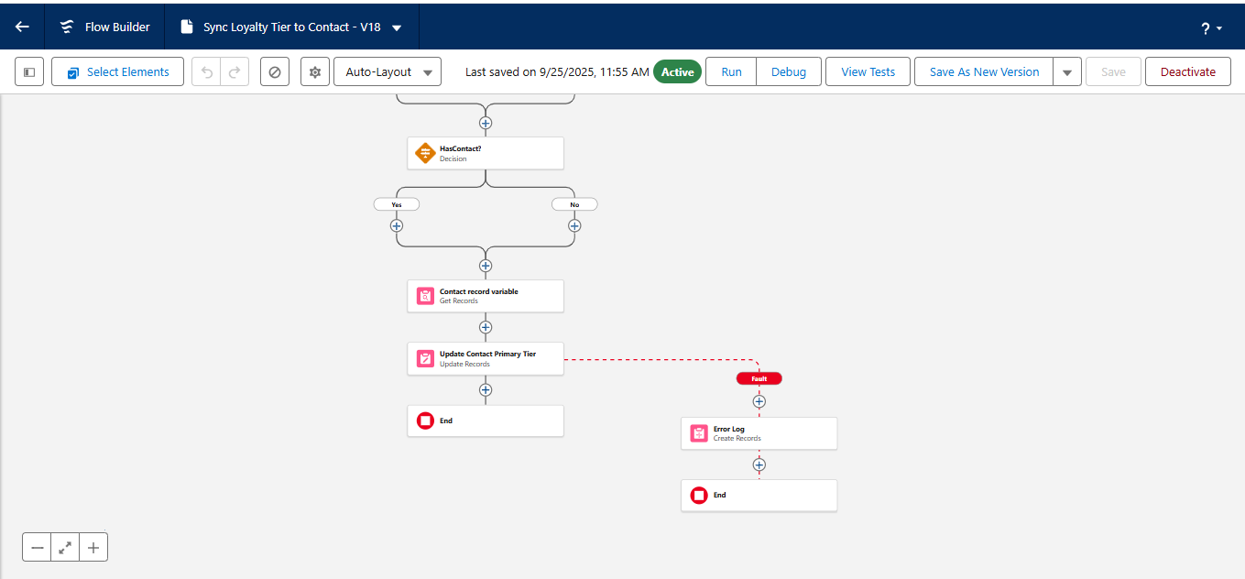

**2.3 OnDelete Recompute Primary Tier**

**Trigger**: Loyalty_Member__c → On Delete.

**Steps inside Flow**:

1. **Get Remaining Loyalty Members** for the Contact.
2. **Decision** → If other loyalty records exist, pick the most recent.
3. **Update Contact** → Reset Primary_Loyalty_Tier__c to remaining member’s tier.

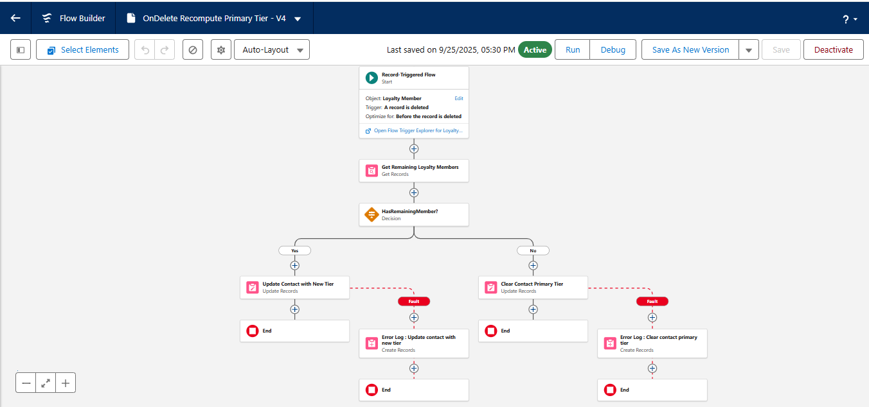

**2.4 Inactive Customer Reengagement Flow**

**Trigger**: Scheduled Path (every week).

**Logic**:

1. **Get Inactive Contacts** → Last_Order_Date__c ≤ cutoff (e.g., 90 days ago).  
   AND Reengagement_Email_Sent__c = False.  
   AND Email ≠ NULL.
2. **Loop through Contacts**.
3. **Send Email Alert** → "We Miss You" template.
4. **Update Contact** → Set Reengagement_Email_Sent__c = True.
5. **Create Task** → Assign follow-up task to Support Agent.

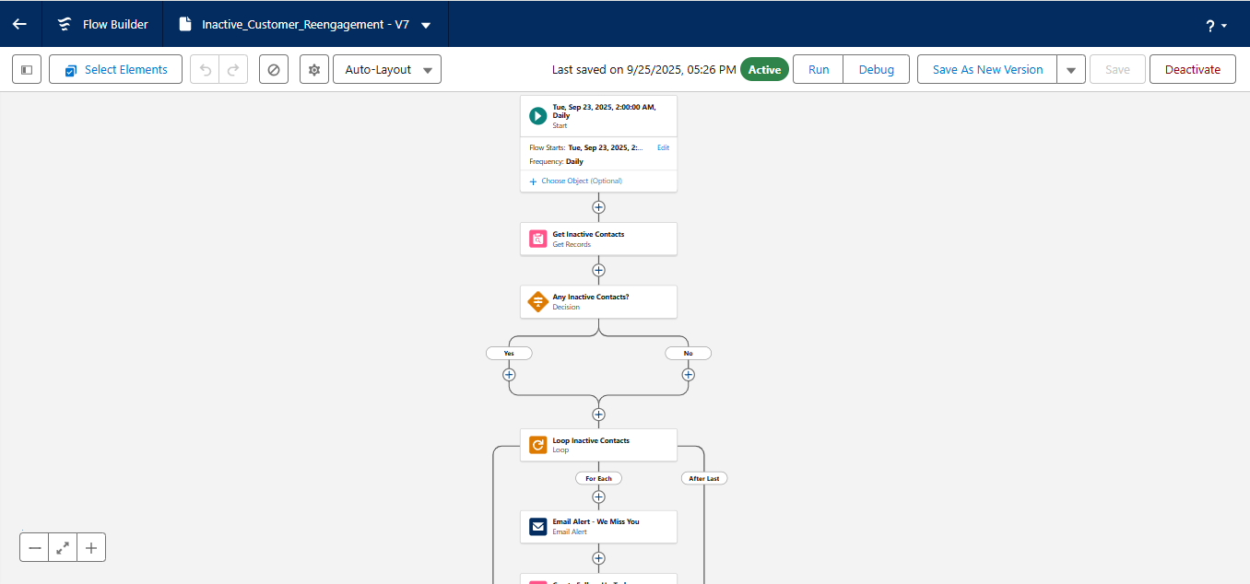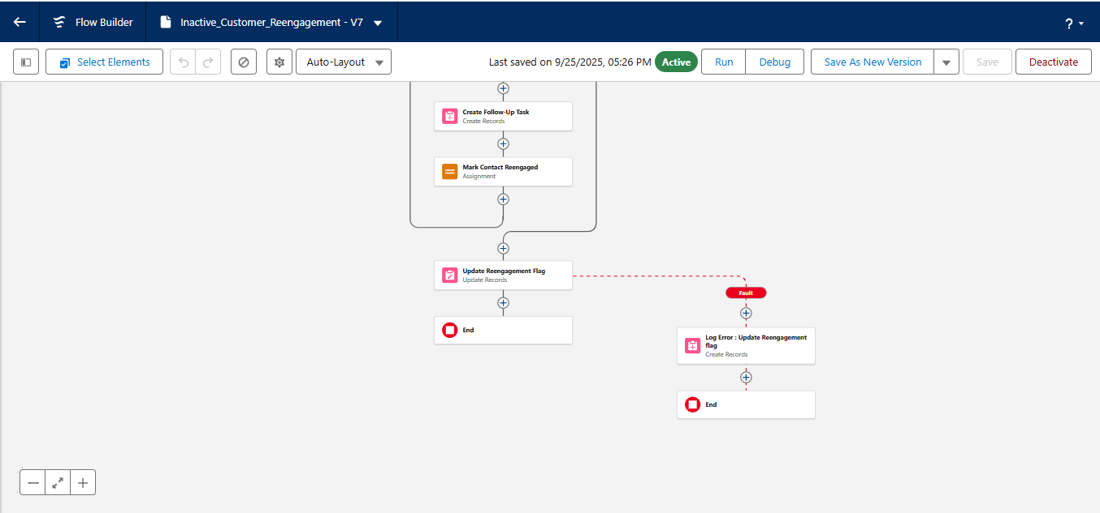

**2.5 Claim Reward Portal Flow**

**Type**: Screen Flow (runs in customer portal).

**Steps**:

1. **Get Loyalty Member** for logged-in user ($User.ContactId).
2. **Screen** → Show available points & tier.
3. **Radio Button Choice** → Rewards available (e.g., Voucher ₹100, Voucher ₹500).
4. **Decision** → Check if enough points are available.
5. **Assignment** → Deduct points if valid.
6. **Create Reward Redemption record**.
   * If high-value (> 500 points), trigger Approval Process.
7. **Screen** → Show Success or Not Enough Points message.

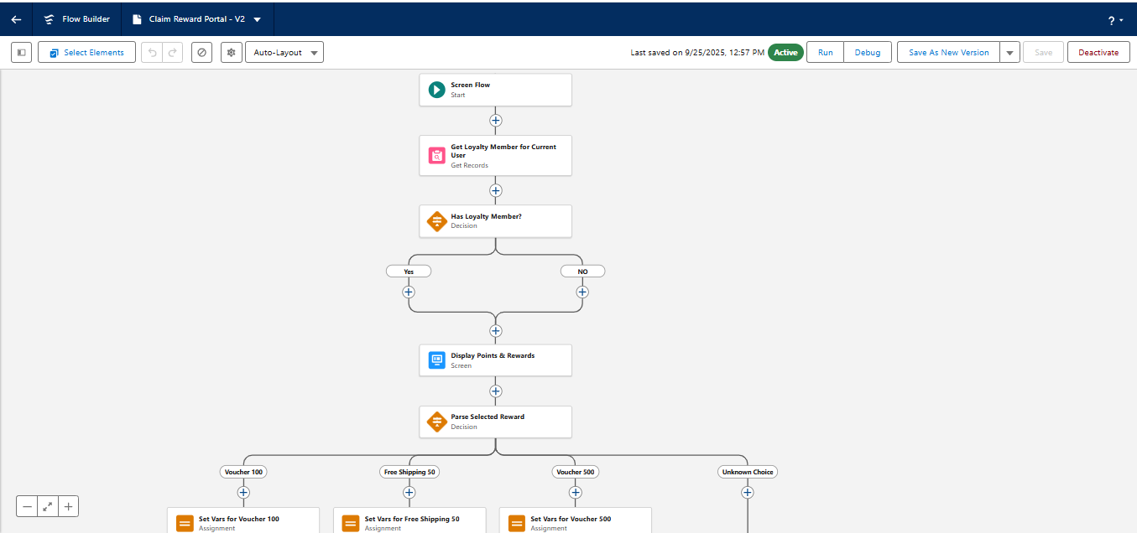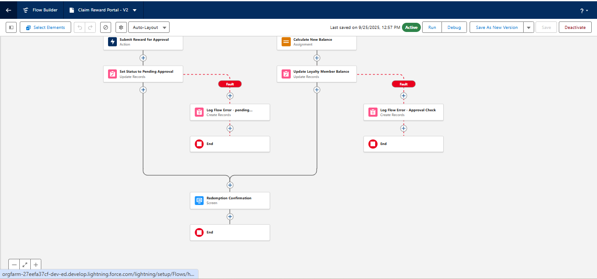

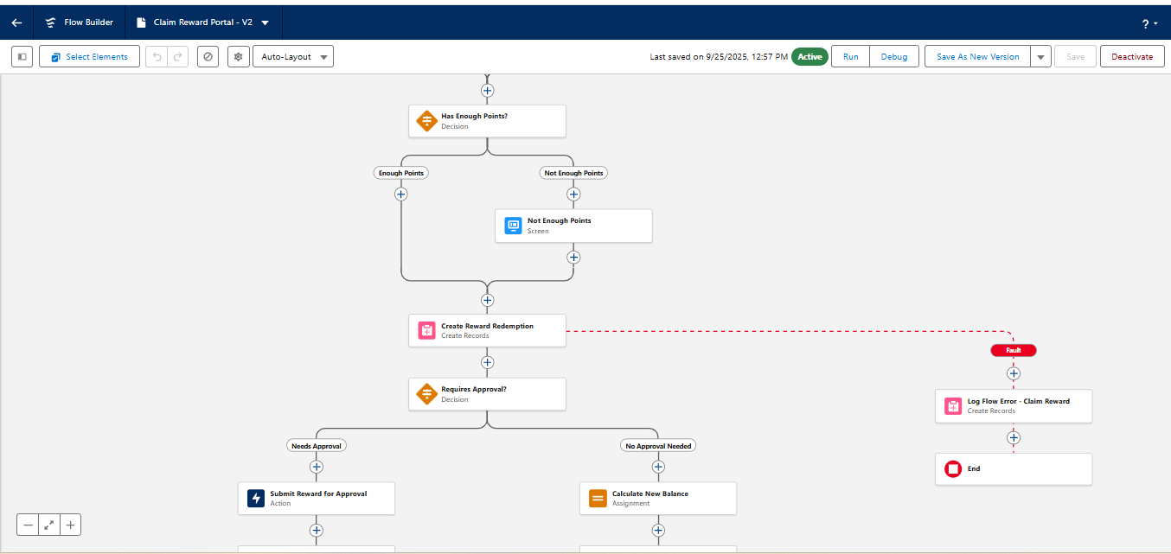

**2.6 Notify Admin of Flow Error**

**Trigger**: Fault paths in other flows.

**Steps**:

1. **Create Error Log** record in Error_Log__c.
2. **Send Email** to Admin with error details.

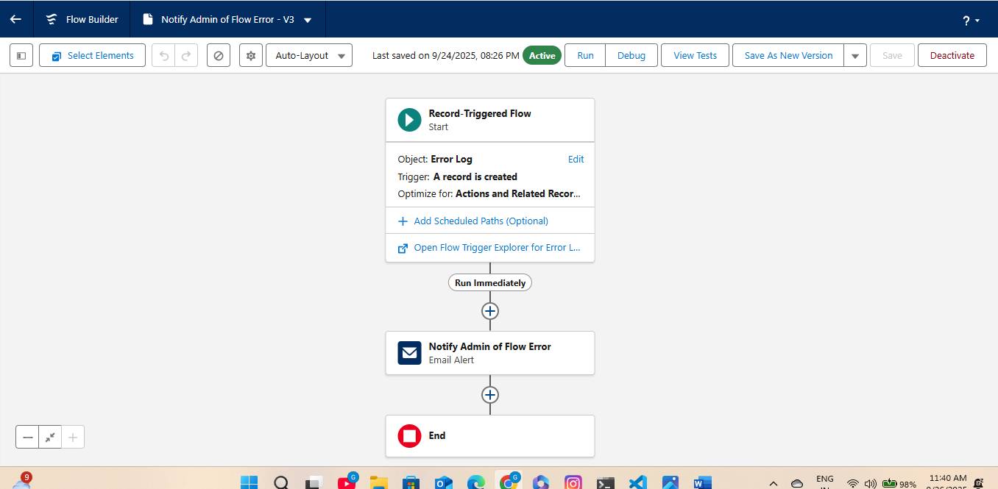

**3. Approval Processes Integrated with Flows**

We created **Approval Processes** for records that require manager review:

1. **Contact Manager Approval**
   * Used when updating sensitive Contact information.
   * Auto-routed to the Contact’s Manager.
2. **High-Value Reward Redemption Approval**
   * If Reward Redemption > 500 points.
   * 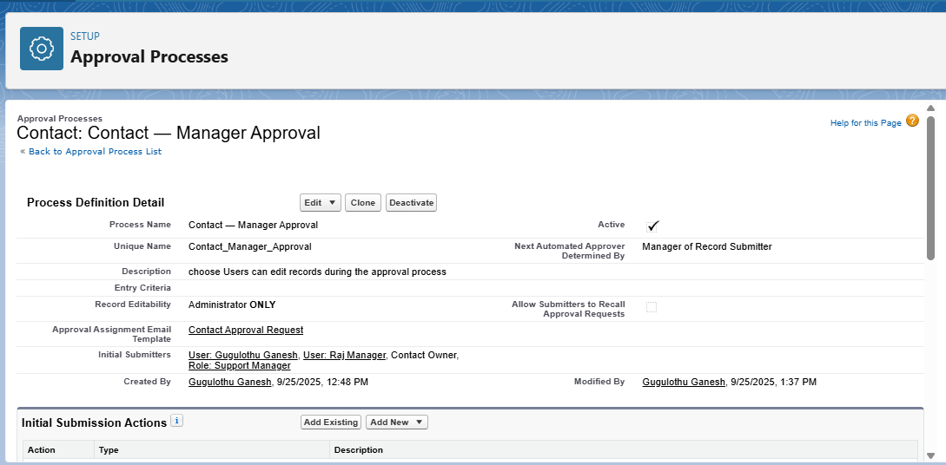Sent to Support Manager for review.

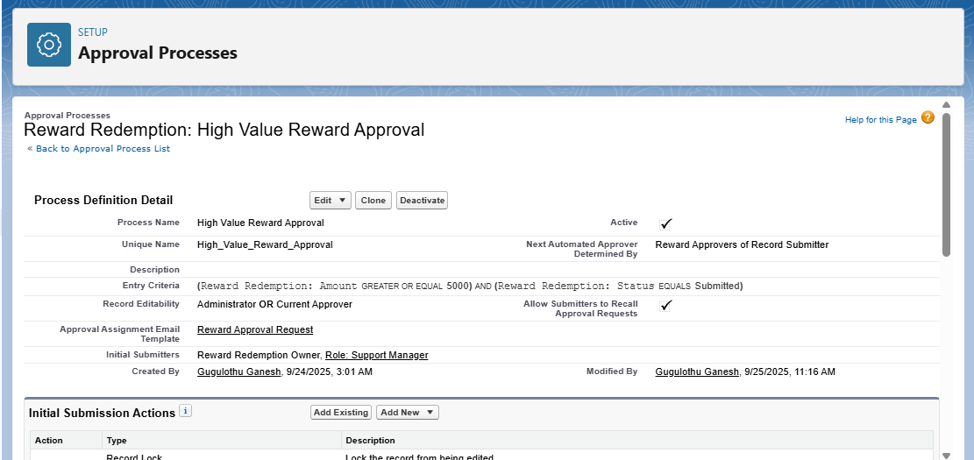

**4. Error Handling**

Every Flow includes **Fault Paths**:

* Logs the error to Error_Log__c.
* Sends admin notification via "Notify Admin of Flow Error".

This ensures no silent failures in automation.

1. **Summary of Phase 3**

At the end of Phase 3, we had:  
✔ Automated loyalty points calculation.  
✔ Automated tier sync to Contact.  
✔ Automated inactive customer reengagement.  
✔ Customer portal reward redemption working.  
✔ Error logging + notifications to admin.  
✔ Approval processes integrated with flows